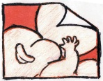
 Queen Mary Hospital/Tsan Yuk Hospital
Breast Feeding Promotion Committee
2014World Breastfeeding Week (1-7 August)
Enrollment form for photo contest
(A moment of Touch)
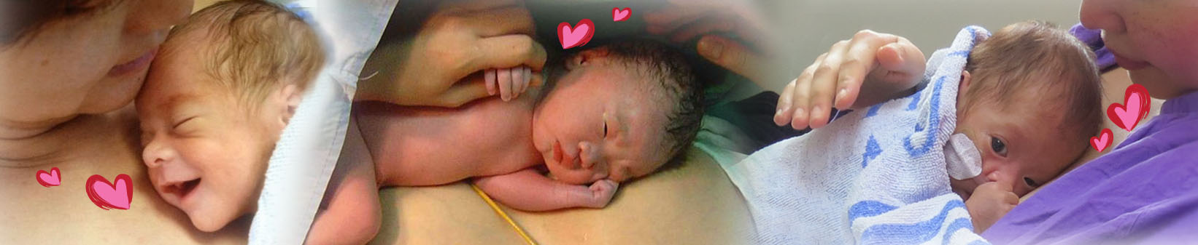

A moment of Touch:
“Interpreting the benefits of breastfeeding and skin-to-skin contact (Kangaroo Care) through the lights and shadows of an image”

Name | ： | _____________________
Gender | ：_______________________ HKID No(First 4 digits )：___________XX(X)
Contact no | ：_______________________
E-mail | ：______________________________________________________
Category : | Parent group Staff Group
Theme | ：
Description of photo: （within 50 words）

Eligibility of Entrants
- We welcome entrants who are the baby’s parents, or family members, or staff of the Hong Kong West Cluster
- The subject of the photo should be baby less than one year old
Terms and Declaration
- Please complete the enrollment form together with the entry (the photo can be color or “black & white” in 8R size, with a caption and description less than 50 words in either Chinese or English). The print format entries can be directly sent or mailed to “ K10N, 10/F, Block K, Queen Mary Hospital, Pokfulam Hong Kong” and written with “World Breast feeding Week 2014 Photo Contest” on the envelop, or email the digital format entries (must be delivered in JPEG format file and no more than 10 mega pixels) with the enrollment format mct006@ha.org.hk.
- The details of the contest and enrollment form can be downloaded from the HKWC intranet.
- Each entrant can submit one entry only. The entry should be a single work of original material taken by the entrant and it has not been published or been awarded; and must not infringe the copyright, trademark, privacy, publicity or other personal or property rights of any person or entity. Mount or frame for the photo is not required.
- The Queen Mary Hospital/Tsan Yuk Hospital Breast Feeding Promotion Committee (QMH/TYH BFPC) reserves the right of exhibiting or using the entries for publicity purpose in any form of media to promote BF as well as the Baby-Friendly Hospital Initiative campaign.
- All entries will not be returned regardless of awarded.
- The judging panel will determine winner eligibility in its sole and absolute discretion.
- The organizer reserves the right of final decision.
Prizes
- A champion, a first runner-up and a second runner-up for each category
- Awards for all winners

Photo Contest result Announcement
Shortlisted awardees will receive a call and email notification, and will be invited to the celebrating World Breastfeeding Week –cum- Photo contest award ceremony dated 2nd August 2014.

Enquires
For enquiries, please call Mr. Pang at 2255-5988 or Ms. Ho at 2255-1099 within the office hours (9:00 am to 5:00 pm, Monday to Friday).

-----------------------------------------------------------------------------------------------------------------------
I understand and agree the terms stated above. I also agree that my photo will be used for any BF promotion events held by Queen Mary Hospital/Tsan Yuk Hospital Breast Feeding Promotion Committee including exhibition and publication in any form of media without payment to and notification.

-------------------------------------------
Signature of Entrant

